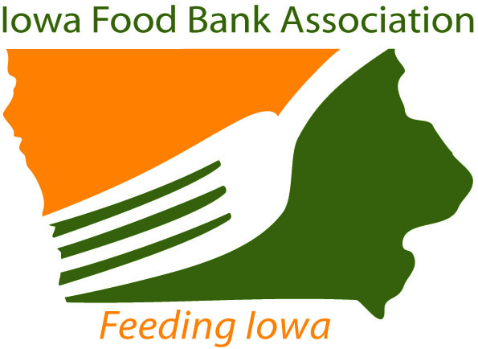
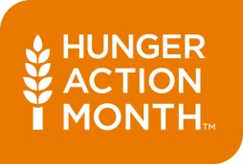
ADVOCATE
INVITATION
Iowa Food Bank Association
contact: Cory Berkenes
phone: 319-290-5596
email: cberkenes@iowafba.org
web: www.iowafba.org

Governor Terry E. Branstad to Proclaim September Hunger Action Month

What: News conference to proclaim Hunger Action Month with Governor Terry Branstad, Lt. Governor Kim Reynolds, and the Iowa Food Bank Association, Iowa Food & Family Project, Iowa Soybean Association, Midwest Dairy, and Iowa Select Farms

Date: Wednesday, August 13, 2014

Time: 1:30 pm

Location: Iowa State Fair, Varied Industries Building, Southeast Atrium

Please join the Iowa Food Bank Association in conjunction with the Iowa Food & Family Project exhibit, What farmers grow makes Iowa go, on Wednesday, August 13, 2014 at 1:30 pm for a special news conference to celebrate and proclaim the month of September National Hunger Action Month.

With a special reading and signing of the National Hunger Month proclamation, Governor Terry E. Branstad and Lieutenant Governor Kim Reynolds will kick-off a month-long focus on food-security awareness and action. Also speaking will be statewide partners of the Iowa Food Bank Association: Iowa Soybean Association (speaking on Invest an Acre - Grain Gifting Program), Midwest Dairy (speaking on the Great American Milk Drive), and the Deb and Jeff Hansen Foundation (speaking on the Backpack Coupon Program).

Iowa Food Bank Association “Fighting Hunger in Iowa” t-shirts will be given to all advocates planning to attend the proclamation signing. To reserve your shirt, please email advocacy@iowafba.org.

# # # END # # #

The Iowa Food Bank Association is a collaborative effort of the eight food banks in Iowa that serve all of its 99 counties. The mission of the Iowa Food Bank Association is to coordinate efforts to alleviate hunger by supporting Feeding America food banks that serve Iowa. Association members include: Food Bank of Iowa, HACAP Food Reservoir, Northeast Iowa Food Bank, River Bend Foodbank, Food Bank for the Heartland, Food Bank of Southern Iowa, Food Bank of Siouxland and St. Stephen’s Food Bank.

