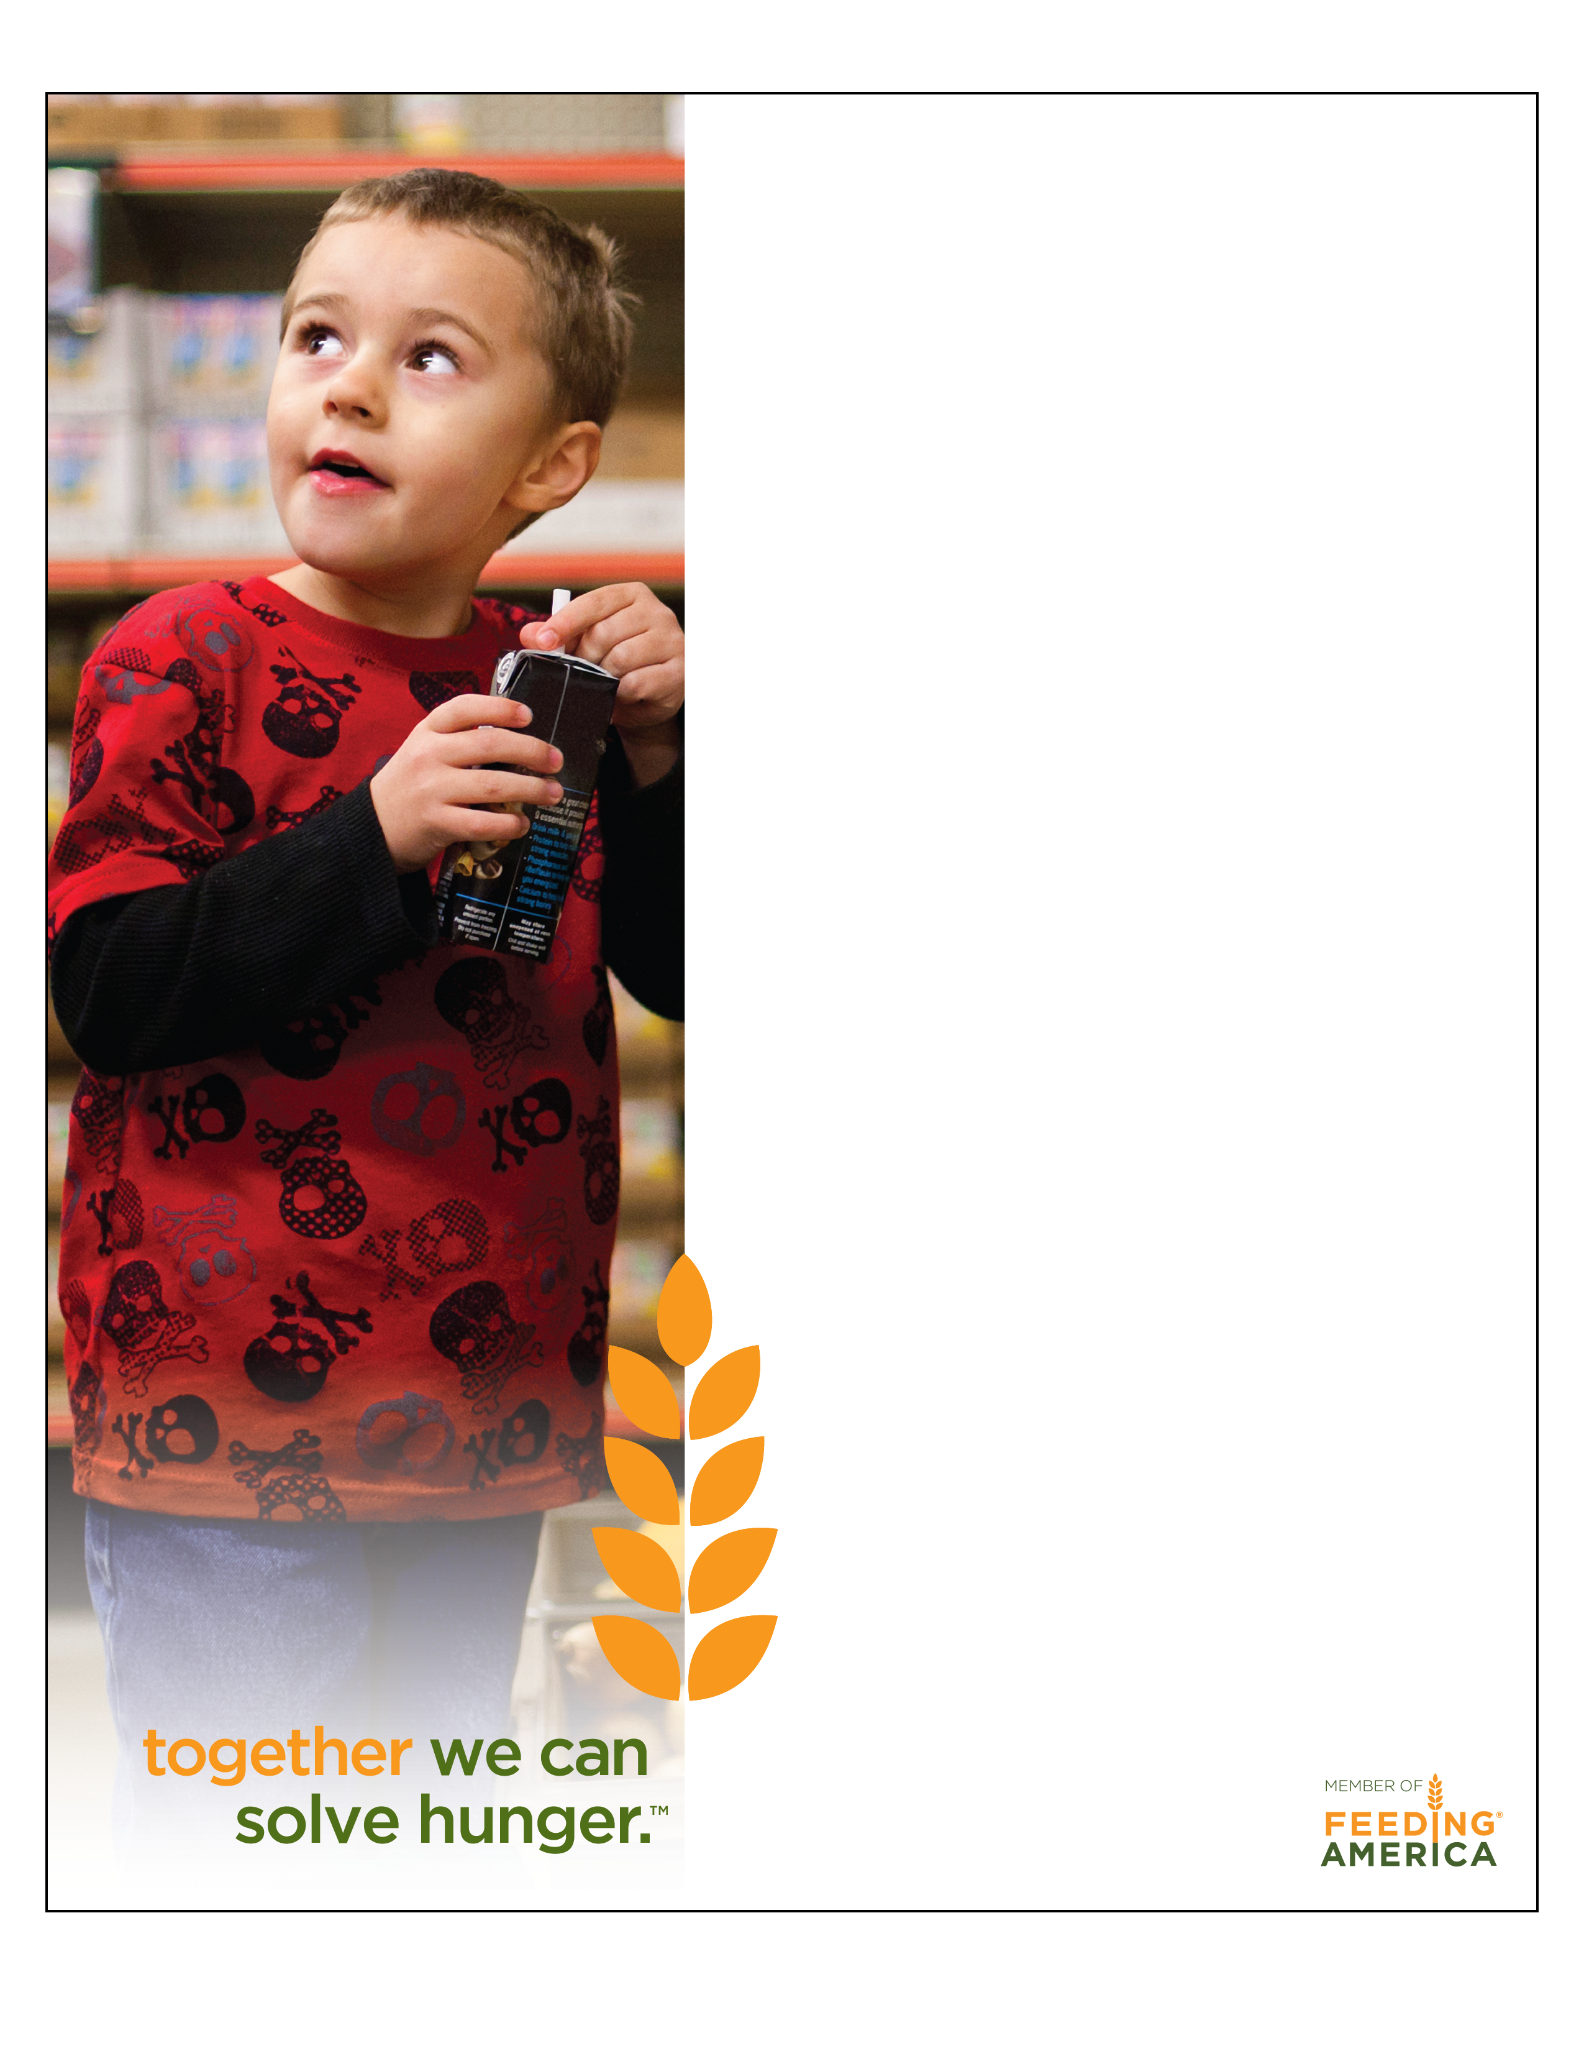

Delete yellow box and place Food Bank logo here.

Iowa Emergency Food Purchase Program

(**Insert City, State, & Date**) **-** 395,620 Iowans are food insecure. That means they do not have dependable access to enough food to sustain a healthy life. More than 137,000 of them are children. The Iowa Emergency Food Purchase Program (IEFPP) is designed to help Iowa’s Eight Feeding America Food Banks purchase nutritious foods to help alleviate hunger in Iowa.

The 2013 legislative session approved the Iowa Emergency Food Purchase Program (IEFPP) to provide a public dollar-for-dollar match of private contributions up to $1 million dollars for Iowa food banks to purchase food for distribution to emergency feeding organizations. All private contributions collected July 1, 2013 through June 30, 2014 are eligible for public match.

In order for private cash contributions to be eligible for state match, contributions:, 1) be received by a food bank serving the state of Iowa; 2) must be used to purchase food that will be distributed to emergency feeding organizations in Iowa; and 3) must NOT be used as match for any other state or federal program or private grant.

In using this program, (**Insert name of local Food Bank**), will be able to purchase food to distribute to local emergency feeding agencies within our local communities, thus helping to feed those who are in need of food to sustain a healthy lifestyle.

Alleviating hunger requires a collaborative effort between Iowa’s Food Banks and the community we live in. With the bulk purchasing power and efficient distribution network of **(Insert Food Bank)**, monetary donations can go further than traditional food donations– for every dollar donated, 4 meals can be purchased for Iowa families in need.

To learn more about how IEFPP directly affects your local community contact **(insert food bank)** at **(Insert phone number).**

Visit **(insert Foodbank website)** or go to [www.iowafooddrive.org](http://www.iowafooddrive.org) to donate today!

###END###

